Name: Hanzla Nouman

Registration No.: FA21-BSE-015

Algorithm #1: Reversed Array

s

**CFG:**

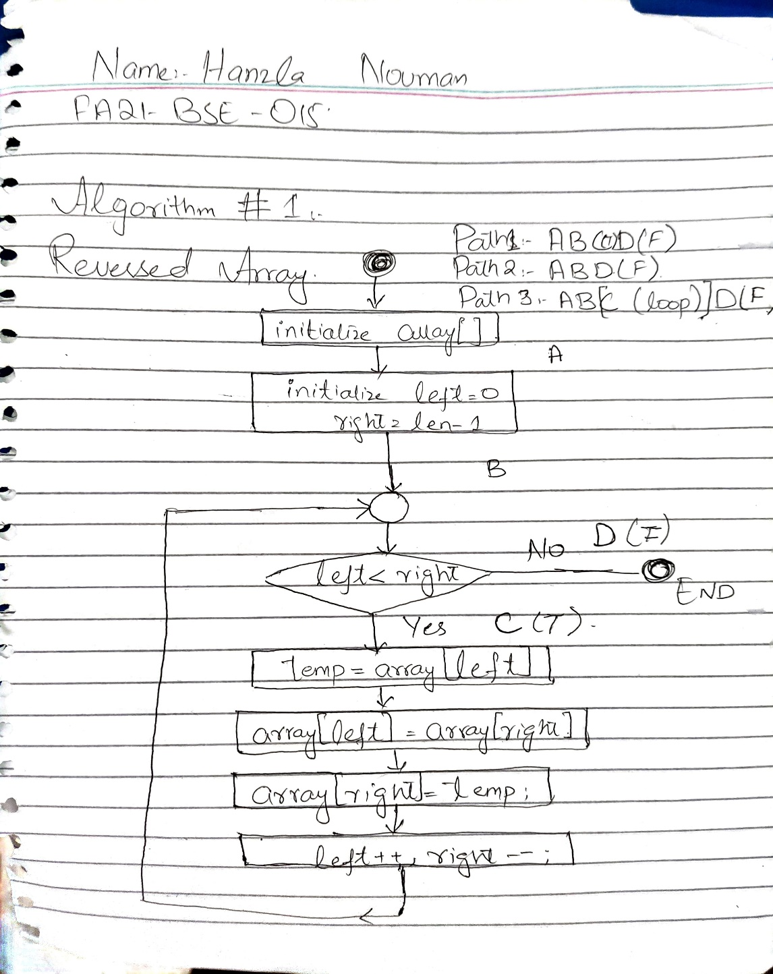

**Test Cases:**

**Test Case 1:**

Empty Array

|  |  |  |  |  |  |
| --- | --- | --- | --- | --- | --- |
| Test ID | Test Description | Input Data | Expected Outcome | Actual Outcome | Remarks/Status |
| 1 | Reversing an Empty Array | {} – (Empty Array) | {} – Array remains unchanged | {} | Passed |

**Test Case 2:**

Array with Single Item

|  |  |  |  |  |  |
| --- | --- | --- | --- | --- | --- |
| Test ID | Test Description | Input Data | Expected Outcome | Actual Outcome | Remarks/Status |
| 1 | Reversing an Array with only 1 element | {3} | {3} – Array remains unchanged | {3} | Passed |

**Test Case 3:**

Array with two elements.

|  |  |  |  |  |  |
| --- | --- | --- | --- | --- | --- |
| Test ID | Test Description | Input Data | Expected Outcome | Actual Outcome | Remarks/Status |
| 1 | Reversing an Array with two elements | {3,1} | {1,3} – Two Items swapped | {1,3} | Passed |

**Test Case 4:**

Array with multiple elements.

|  |  |  |  |  |  |
| --- | --- | --- | --- | --- | --- |
| Test ID | Test Description | Input Data | Expected Outcome | Actual Outcome | Remarks/Status |
| 1 | Reversing an Array with multiple elements | {3,1,6,4,7} | {7,4,6,1,3} | {7,4,6,1,3} | Passed |

**Code:**

Attached as IntelliJ Project with Maven.

Test Code:

import org.example.ReverseArray;  
import org.junit.Test;  
import static org.junit.Assert.*assertArrayEquals*;  
  
public class ReverseArrayTest {  
  
 @Test  
 public void testEmptyArray() {  
 int[] actual = {};  
 ReverseArray.*reverseArray*(actual);  
  
 *assertArrayEquals*(new int[]{}, actual);  
 }  
  
 @Test  
 public void testSingleElementArray() {  
 int[] actual = {7};  
 ReverseArray.*reverseArray*(actual);  
  
 *assertArrayEquals*(new int[]{7}, actual);  
 }  
  
 @Test  
 public void testTwoElementArray() {  
 int[] actual = {1, 2};  
 ReverseArray.*reverseArray*(actual);  
 int[] expected = {2, 1};  
 *assertArrayEquals*(expected, actual);  
 }  
  
 @Test  
 public void testMultiElementArray() {  
 int[] actual = {4, 3, 2, 1};  
 ReverseArray.*reverseArray*(actual);  
 int[] expected = {1, 2, 3, 4};  
 *assertArrayEquals*(expected, actual);  
 }  
  
 @Test  
 public void testLongerMultiElementArray() {  
 int[] actual = {1, 2, 3, 4, 5};  
 ReverseArray.*reverseArray*(actual);  
 int[] expected = {5, 4, 3, 2, 1};  
 *assertArrayEquals*(expected, actual);  
 }  
}

Code:

package org.example;  
  
public class ReverseArray {  
 public static void main(String[] args) {  
 int[] array = {1, 2, 3, 4, 5}; // Example array, you might want to replace or generate dynamically  
 *reverseArray*(array);  
 for (int num : array) {  
 System.*out*.print(num + " ");  
 }  
 }  
  
 public static void reverseArray(int[] array) {  
 int left = 0, right = array.length - 1;  
 while (left < right) {  
 int temp = array[left];  
 array[left] = array[right];  
 array[right] = temp;  
 left++;  
 right--;  
 }  
 }  
}